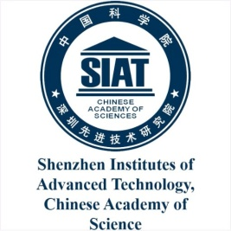

Russian-Chinese school
on biomedical engineering and mathematical modeling

12.01: arrival and accommodation
13.01: cultural program
14.01:
9.30-13.00 Lin Wang , Sport Biomechanics
13.00-14.00 Lunch
14.00-17.00 Igor Konshin, Introduction to supercomputing
15.01:
10.00-13.00 Anatoly Shipilov, Practical training in sport biomechanics (http://cstsk.ru/)
13.00-14.30 Transfer and Lunch
14.30-17.30 Alexander Danilov, Introduction to personalized mathematical modeling
16.01:
10.00-13.00 Svetlana Kotova, Measurement of nanomechanical properties of soft tissues and cells
13.00-14.00 Lunch
14.00-17.30 Lin Wang, Sport Biomechanics
17.01:
10.00-13.00 Anatoly Shipilov, Practical training in sport biomechanics (http://cstsk.ru/)
13.00-14.30 Transfer and Lunch
14.30-17.30 Igor Konshin, Introduction to supercomputing
18.01:
10.00-13.00 Victoria Salamatova, Hyperelasticity and biomechanics
13.00-14.00 Lunch
14.00-17.00 Igor Konshin, Introduction to supercomputing
19.01: Cultural program
20.01: Departure

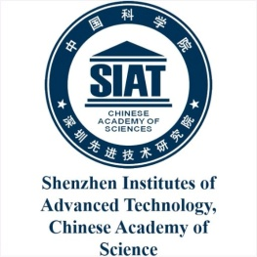

Russian-Chinese school
on biomedical engineering and mathematical modeling

12.01: arrival and accommodation
13.01: cultural program
14.01:
9.30-13.00 Lin Wang , Sport Biomechanics
13.00-14.00 Lunch
14.00-17.00 Igor Konshin, Introduction to supercomputing
15.01:
10.00-13.00 Anatoly Shipilov, Practical training in sport biomechanics (http://cstsk.ru/)
13.00-14.30 Transfer and Lunch
14.30-17.30 Alexander Danilov, Introduction to personalized mathematical modeling
16.01:
10.00-13.00 Svetlana Kotova, Measurement of nanomechanical properties of soft tissues and cells
13.00-14.00 Lunch
14.00-17.30 Lin Wang, Sport Biomechanics
17.01:
10.00-13.00 Anatoly Shipilov, Practical training in sport biomechanics (http://cstsk.ru/)
13.00-14.30 Transfer and Lunch
14.30-17.30 Igor Konshin, Introduction to supercomputing
18.01:
10.00-13.00 Victoria Salamatova, Hyperelasticity and biomechanics
13.00-14.00 Lunch
14.00-17.00 Igor Konshin, Introduction to supercomputing
19.01: Cultural program
20.01: Departure

