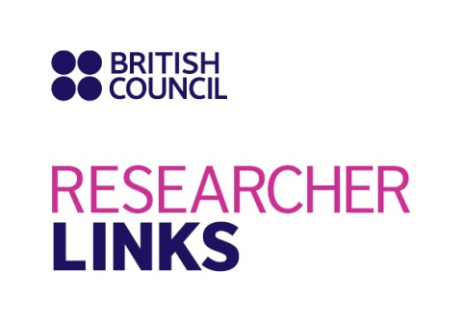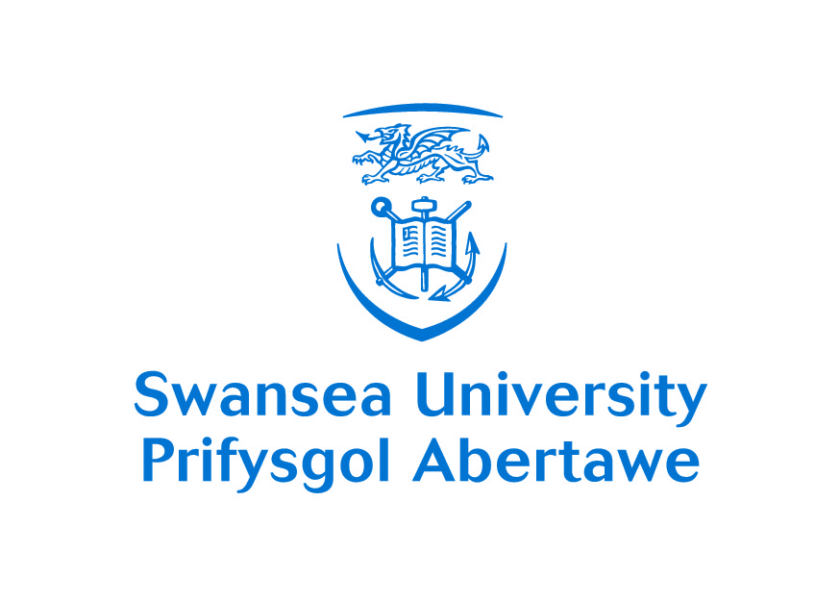

Programme of the British Council Researcher Links Workshop
“Mathematical and Computational Modelling in Cardiovascular Problems”

April 15 (INM RAS) "Heart, patient-specific modelling"
Section I Chairman Perumal Nithiarasu
9.30–9.35 Opening
9.35–10.15 Rubin Aliev (Moscow Institute of Physics and Technology) Computer simulations of electrical activity in the SAN
10.15–10.55 Xiaoyu Luo (University of Glasgow) Dynamic finite-strain modelling of the human left ventricle in health and disease using an immersed boundary-finite element method
10.55–11.20 Coffee break
Section II Chairman Rubin Aliev
11.20–12.00 Andrey Tsaturyan (Lomonosov Moscow State University) A simple kinetic model of cardiac muscle mechanics
12.00–12.40 Olga Solovyova (Institute of Immunology and Physiology RAS) Electro-mechanical and mechano-electrical coupling in myocardium from molecules to tissue: model predictions and experimental verifications
12.40–13.30 Lunch
Section III Chairman Xiaoyu Luo
13.30–14.00 Jordi Alastruey (King’s College London) Arterial pulse wave propagation: modelling and analysis
14.00–14.20 Claudio Capelli (University College London) Translating patient-specific simulations into clinics: early results and current challenges
14.20–14.40 Ramón Casero Cañas, (University of Oxford) Building a detailed anatomical model of the rat heart
14.40–15.00 Hao Gao (University of Glasgow) Fluid structure interaction of left ventricle modelling from diastole to systole based on in-vivo CMR
15.00–15.20 Giovanni Biglino (University College London) Imaging-based wave intensity analysis and statistical shape analysis to unravel the problem of ventriculo-arterial coupling in congenital heart disease
15.20–15.40 Adelaide de Vecchi (King’s College London) A novel methodology to simulate ventricular dynamics in congenital heart disease from advanced 3D+t echocardiography data
15.40–16.00 Spyridon Tzamtzis (University College London) Numerical simulations in the development of new generation TAVI devices
16.00–16.20 Coffee break
Section IV Chairman Olga Solovyova
16.20–16.40 Roman Syunyaev (Institute of Theoretical and Experimental Biophysics RAS) Computer simulations of reentrant activity in SAN
16.40–17.00 Svyatoslav Solodushkin (Ural Federal University) Statistical analysis of predictors of myocardial infarction after total hip replacement in patients over 60 years
17.00–17.20 Alexander Danilov (Institute of Numerical Mathematics RAS) High resolution human body computational models
17.20–17.30 Svetlana Maltseva (Sobolev Institute of Mathematics RAS) Reconstruction of the mouse brain vasculature according to the tomographic data
17.30–17.40 Yuri Ivanov (Institute of Numerical Mathematics RAS) Patient specific reconstruction of vascular network for haemodynamic modelling
17.40–17.50 Alexander Kursanov (Institute of Immunology and Physiology RAS) Effect of mechanical factors on rhythm disturbances in mathematical model of cardiac fiber with local Ca2+-overloading
17.50–18.00 Yulia Korneva (Smolensk State Medical Academy) Morphometric parameters of myocardium as substrate for mathematical modeling of myocardial infarction healing
18.00–18.10 Fedor Syomin (Lomonosov Moscow State University) A cylindrical model of contraction of left ventricle of the heart
Discussion
18.10–18.30 Early Career Ideas
April 16 (INM RAS) "Blood flows, patient-specific modelling"
Section V Chairman Sergey Mukhin
9.30–10.10 Igor Sazonov (Swansea University) Constructing geometries for the patient specific modelling
10.10–10.50 Yun Xu (Imperial College London) Computational modelling of type B aortic dissection: predicting the need for intervention
10.50–11.10 Coffee break
Section VI Chairman Yun Xu
11.10–11.50 Sergey Mukhin (Lomonosov Moscow State University) Hemodynamic modeling: fundamental and practical approaches
11.50–12.30 Perumal Nithiarasu (Swansea University) 1D systemic circulation models for clinical applications
12.30–13.20 Lunch
Section VII Chairman Jordi Alastruey
13.20–13.50 Xianghua Xie (Swansea University) Computer vision in biomedical applications
13.50–14.10 Rhodri Bevan (University of Bristol) Investigation of wall shear stress derived risk factors on patient-specific cardiovascular geometries
14.10–14.30 Chang Park (Institute of Biomedical Engineering, Oxford) Estimating changes to brain oxygenation delivery through multi-scale modelling of the cerebral microvasculature
14.30–14.50 Etienne Boileau (Swansea University) A novel computational framework to study arterial vasomotion
14.50–15.10 Alistair Revell (University of Manchester) Towards embedded simulation of turbulent flow structure interaction, and possibilities for interactive CFD
15.10–15.25 Coffee break
Section VIII Chairman Andrey Tsaturyan
15.25–15.55 Sergey Simakov (Moscow Institute of Physics and Technology) Computational haemodynamics for clinical practice
15.55–16.15 Victoria Salamatova (Moscow Institute of Physics and Technology) Modelling of soft tissue deformation
16.15–16.35 Alexander Khe (Lavrentyev Institute of Hydrodynamics RAS) Time series analysis using persistent homology methods
16.35–16.50 Tatyana Dobroserdova (Institute of Numerical Mathematics RAS) Numerical simulation of blood flow in the vascular network with pathologies or implants
16.50–17.05 Alexander Cherevko (Lavrentyev Institute of Hydrodynamics RAS) Сerebral aneurysm blood vessel unsteady hemodynamic simulation
17.05–17.20 Coffee break
Section IX Chairman Yuri Vassilevski
17.20–17.35 Dmitry Kulikov (Moscow Regional Research & Clinical Institute “MONIKI”) Development of the method for evaluating the status of blood microcirculation system and the risk of microvascular complications development at diabetes mellitus based on optical spectroscopy
17.35–17.50 Dmitry Nechipurenko (Lomonosov Moscow State University) Modelling initial stages of thrombus growth using revised platelet-platelet interaction model
17.50–18.05 Aleksey Rukhlenko (Moscow Institute of Physics and Technology) Mathematical modeling of blood coagulation processes in intensive blood flow conditions
18.05–18.20 Aleksey Tokarev (National Research Centre for Hematology) Erythrocytes – platelets – fibrin mesh interactions in blood flow as basic elements of the hemostatic and thrombotic processes
18.20–18.30 Elena Pogorelova (Center for Theoretical Problems of Physicochemical Pharmacology RAS) A mathematical model for blood clot growth based on “advection—diffusion” equations
18.30–18.40 Igor Gudich (Federal Research and Clinical Centre of Pediatric Hematology, Oncology and Immunology) One computational approach to the high level model of platelet thrombus formation in the flow
18.40–18.50 Timur Gamilov (Moscow Institute of Physics and Technology) Modelling of passive blood flow stimulation
18.50–19.00 Denis Lapitan (Moscow Regional Research & Clinical Institute “MONIKI”) Development of backscattered optical radiation model for measuring parameters of the blood microcirculation system
19.00–19.10 Vasily Kramarenko (Moscow Institute of Physics and Technology) Natural user interfaces for mathematical models dealing with real human anatomy
19.30–21.30 Dinner
April 17 (MIPT, metro Tretyakovskaya, Klimentovsky pereulok 1, bld.1)
International Round Table "Mathematical and Computational Modelling in Cardiovascular Problems: Forms of International Collaboration" Chairman Igor Sazonov
9.30– 9.55 Yuri Vassilevski (Institute of Numerical Mathematics RAS) Working group on mathematical models and numerical methods in biomathematics
9.55–10.20 Permural Nithiarasu (Swansea University) Conferences, journals and funding opportunities in the area of biomedical modelling
10.20–10.45 Ospan Mynbaev (New European Surgical Academy) Translational medicine & biomodeling: the bonding force for multidisciplinary researches
10.45–11.10 Andrey Tsaturyan (Lomonosov Moscow State University) Long-term Russian-British collaboration in studying structure-function relation in muscle
11.10–11.30 Inna Trusova (Moscow Institute of Physics and Technology) Simulational medicine
11.30–11.50 Marina Sokolova (UK Science & Innovation Network, British Embassy) UK-Russia collaboration in science and funding opportunities
11.50–12.20 Discussion
12.30–13.30 Lunch
13.45–15.00 Excursion to Tretyakov gallery (collection of Russian art)
15.00–17.00 Walking tour in the city centre
April 18
12.00-13.30 Excursion inside Kremlin

